NEURAL NETWORK
EXPERIMENT-2
DIVYANK PARIHAR ( 24UADS1019)
OBJECT - To implement a single-layer Perceptron neural network for realizing the AND logic gate using Python, and to study its learning behavior through weight updates, error analysis, and decision boundary visualization.
SOURCE CODE -
import numpy as np
import matplotlib.pyplot as plt
import matplotlib
matplotlib.use('Agg')
import time

# AND gate dataset
X = np.array([
[0, 0],
[0, 1],
[1, 0],
[1, 1]
])

T = np.array([0, 0, 0, 1]) # Targets for AND gate

# Add bias input (x0 = 1)
X_bias = np.c_[np.ones(X.shape[0]), X]

# Initialize weights to zero (bias + 2 inputs)
W = np.zeros(X_bias.shape[1])

learning_rate = 0.01
epoch = 0
total_errors = []

def step_function(net):
return 1 if net >= 0 else 0

# Training loop
while True:
epoch += 1
errors = 0
rows = []

print(f"\nEpoch {epoch}")
print("-" * 60)

for i in range(len(X_bias)):
net = np.dot(X_bias[i], W)
y = step_function(net)
error = T[i] - y

# Weight update
W = W + learning_rate * error * X_bias[i]

errors += abs(error)

rows.append([
X[i][0], X[i][1],
T[i], y, error,
W.copy()
])

# Print table (avoid pandas to bypass DLL C-extension issues)
print("{:>3} {:>3} {:>6} {:>9} {:>6} {}".format("x1", "x2", "Target", "Predicted", "Error", "Weights"))
for r in rows:
x1, x2, targ, pred, err, weights = r
print(f"{int(x1):>3} {int(x2):>3} {targ:>6} {pred:>9} {err:>6} {np.array2string(weights, precision=2)})")

total_errors.append(errors)

# ---- Plot decision boundary ----
plt.figure(figsize=(6, 5))

for i in range(len(X)):
if T[i] == step_function(np.dot(X_bias[i], W)):
plt.scatter(X[i][0], X[i][1], color="green", s=100, label="Correct" if i == 0 else "")
else:
plt.scatter(X[i][0], X[i][1], color="red", s=100, label="Wrong" if i == 0 else "")

# Decision boundary: w0 + w1*x + w2*y = 0
if W[2] != 0:
x_vals = np.array([-0.5, 1.5])
y_vals = -(W[0] + W[1] * x_vals) / W[2]
plt.plot(x_vals, y_vals, 'b--', label="Decision Boundary")

plt.title(f"Epoch {epoch}")
plt.xlabel("x1")
plt.ylabel("x2")
plt.legend()
plt.grid()
plt.xlim(-0.5, 1.5)
plt.ylim(-0.5, 1.5)
plt.savefig(f"epoch_{epoch}.png")
plt.close()

time.sleep(2)
# Stop if no error
if errors == 0:
print(f"\n Converged at epoch {epoch}")
break

# ---- Error vs Epoch plot ----
plt.figure(figsize=(6, 4))
plt.plot(range(1, epoch + 1), total_errors, marker='o')
plt.xlabel("Epoch")
plt.ylabel("Total Error")
plt.title("Error vs Epoch")
plt.grid()
plt.savefig("errors_vs_epoch.png")
plt.close()

OUTPUT:
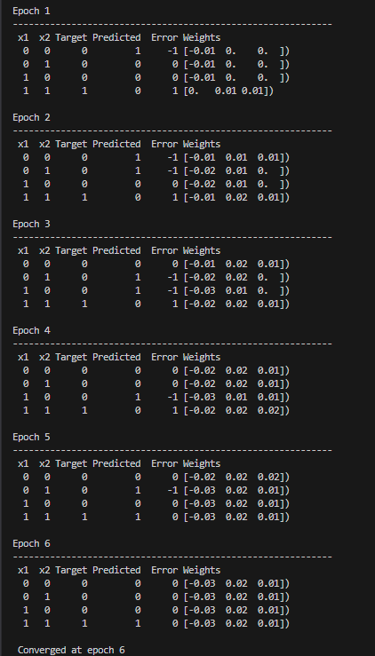

GRAPHS : -

